User's
Manual

guacamole-performance-test.py

Juan C. Riano

Florida International University, Summer 2015
1 General Information

The guacamole-performance-test.py is a script written with the purpose of measuring the performance hit taken by a Linux server running the Guacamole Gateway as remote RDP connections are established.

1.1 System Overview

Guacamole (http://guac-dev.org/) is an HTTP5 Gateway that allows users to connect to remote computers by using open source libraries for the SSH, RDP and VNC protocols.

1.2 System Requirements

- Ubuntu 14.04 web server
- Sysstat for CPU usage measuring (specifically the mpstat command).
- Free (the free command is used for memory usage measuring).
- Guacamole 0.9.6
- Guacamole NoAuth extension (not required)
- Python 2.7
- Pygal (http://pygal.org/) for charting
- RDP computers set up to connect to. (Configuring Guacamole documentation)

2 Environment Setup

Although this document describes a particular setup, other setups could easily be implemented by making sure the needed libraries and / or tools are installed in case they are named differently in other Linux distributions.

Since the script is intended to run while RDP connections are established, it is highly recommended that a test Guacamole environment is used, and that this test environment is running the NoAuth extension (http://guac-dev.org/doc/gug/noauth.html#installing-noauth). Using this extension will allow the tester to quickly open connections without having to provide username/passwords for each connection.

2.1 Test Setup

To run the test quickly, the Guacamole server should be running the NoAuth extension, which allows you to see all the available connections in the main page as shown bellow.
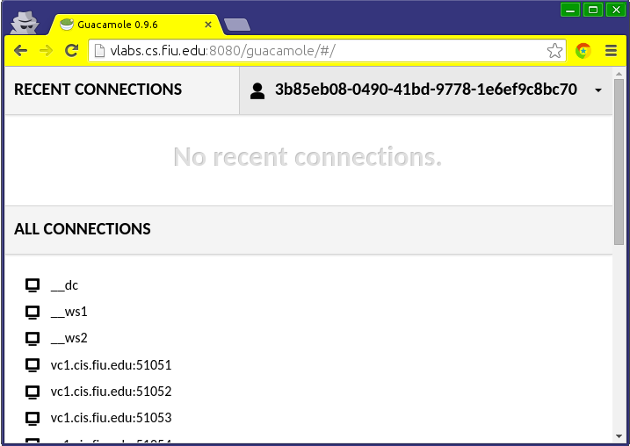

If the test intends to create more than 20 connections, it is better to create an HTML file with the connections' information setup as links, and set this page for easy access to the computers to use for the test.
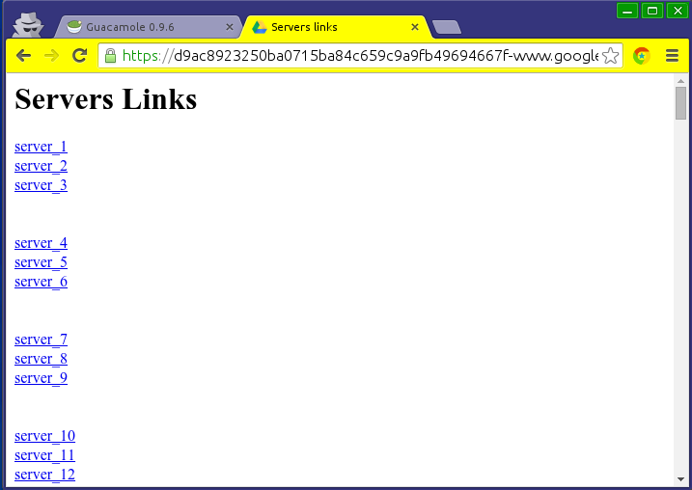

The guacamole-performance-test.py script outputs 5 files in the same folder where it resides, thus, it is recommended to run it from inside an empty folder created just to run the test. This folder can be in any location.

The script needs to be run with sudo, as it needs to read the system logs, which are restricted.

3 Running the Script

The first step is to make sure that the script is executable.
$ chmod +x guacamole-performance-test.py

Then run the script providing the location of the server's system log.
$ sudo ./guacamole-performance-test.py /sys/log/syslog

This will start the script and provide the initial memory and CPU values.
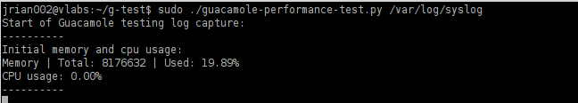

Then as new connections are opened in the Guacamole gateway, the script shows the connections and the changes in memory and CPU usage.
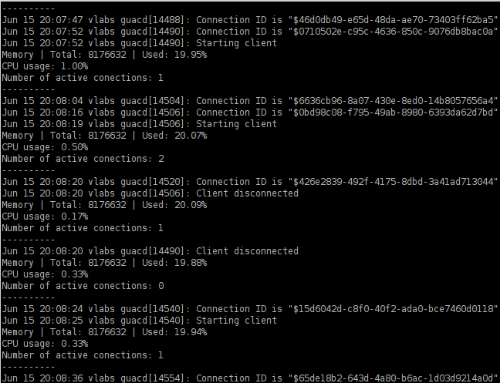

Finally, when the script is stopped with Ctrl-C, the latest values are shown in the terminal, and new files can be found in the folder.
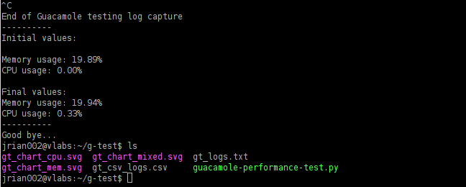

These new files contain the logs in .txt and .csv formats, as well as 3 charts made with those values.
